Task 01

What is a process?
A process is an independent program in execution. It has its own memory space, resources, and system state.
Examples: When we open Chrome, Games or any other application - each is a separate process.

Task 02
What is a thread?
A thread is a smaller part of a process that helps a program do many tasks at the same time. For example, in a web browser (which is a process), one thread might load a webpage, another might play a video.

Task 03
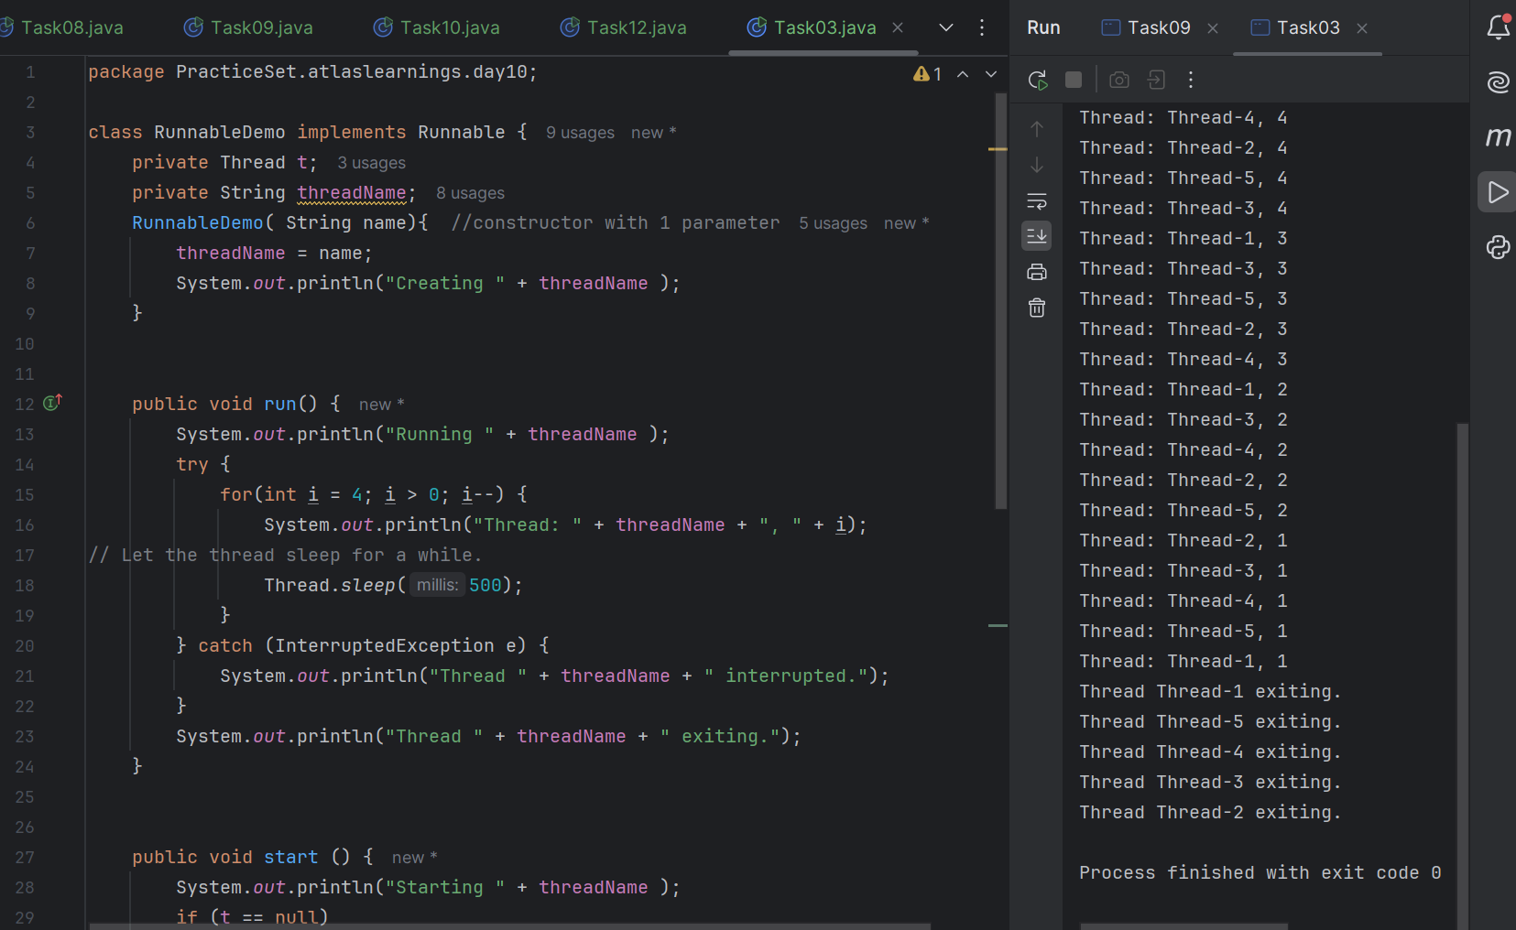

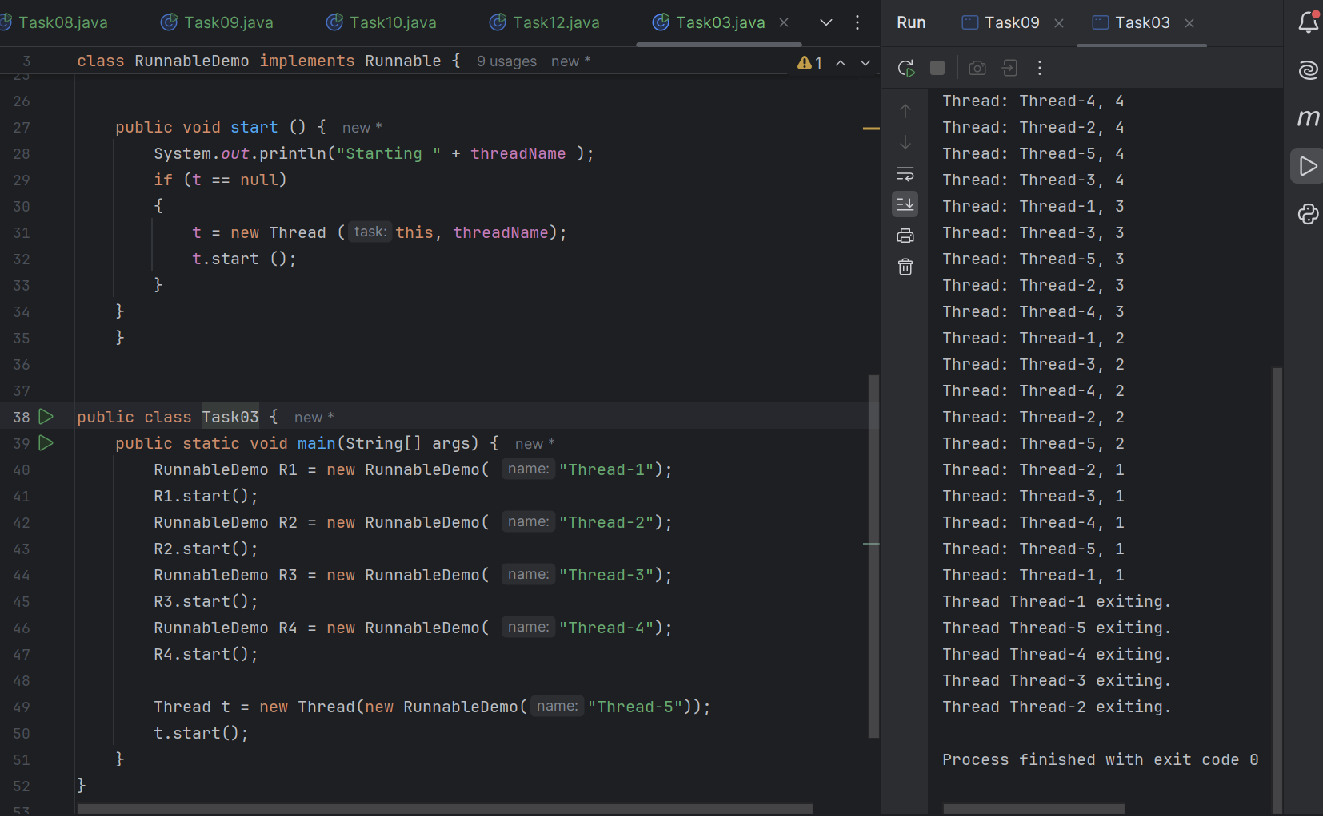

Task 04

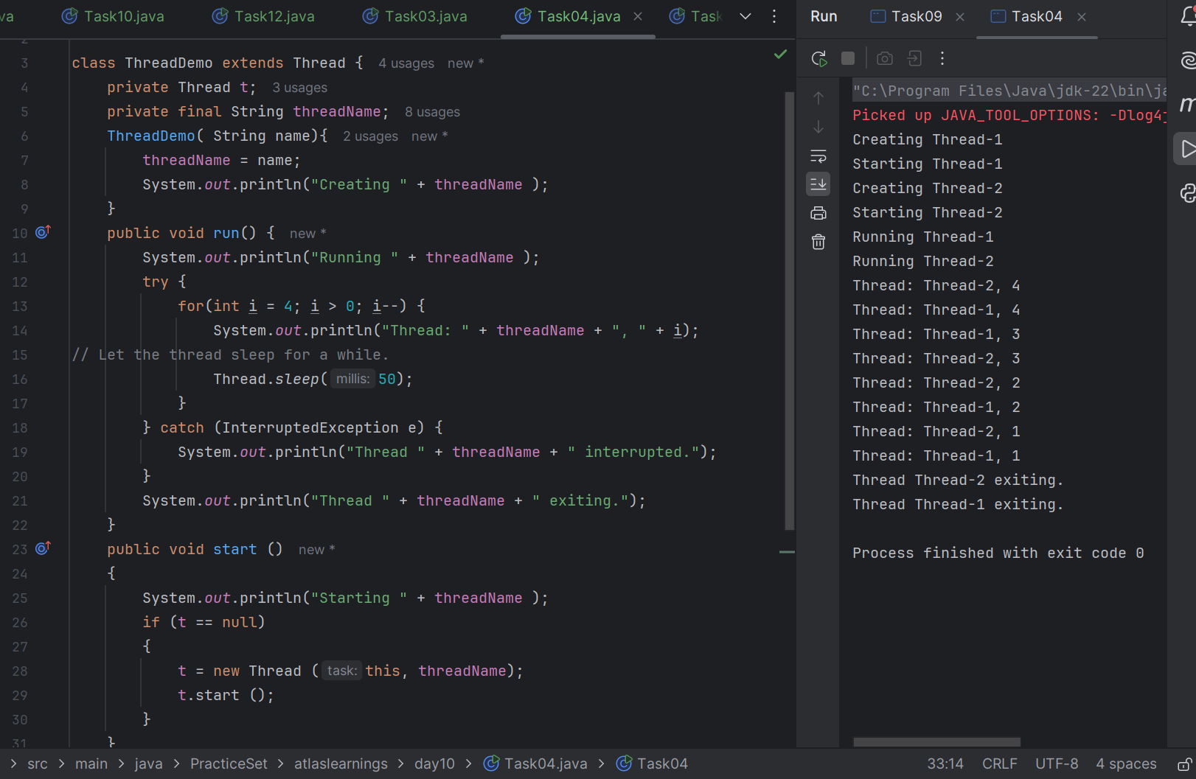
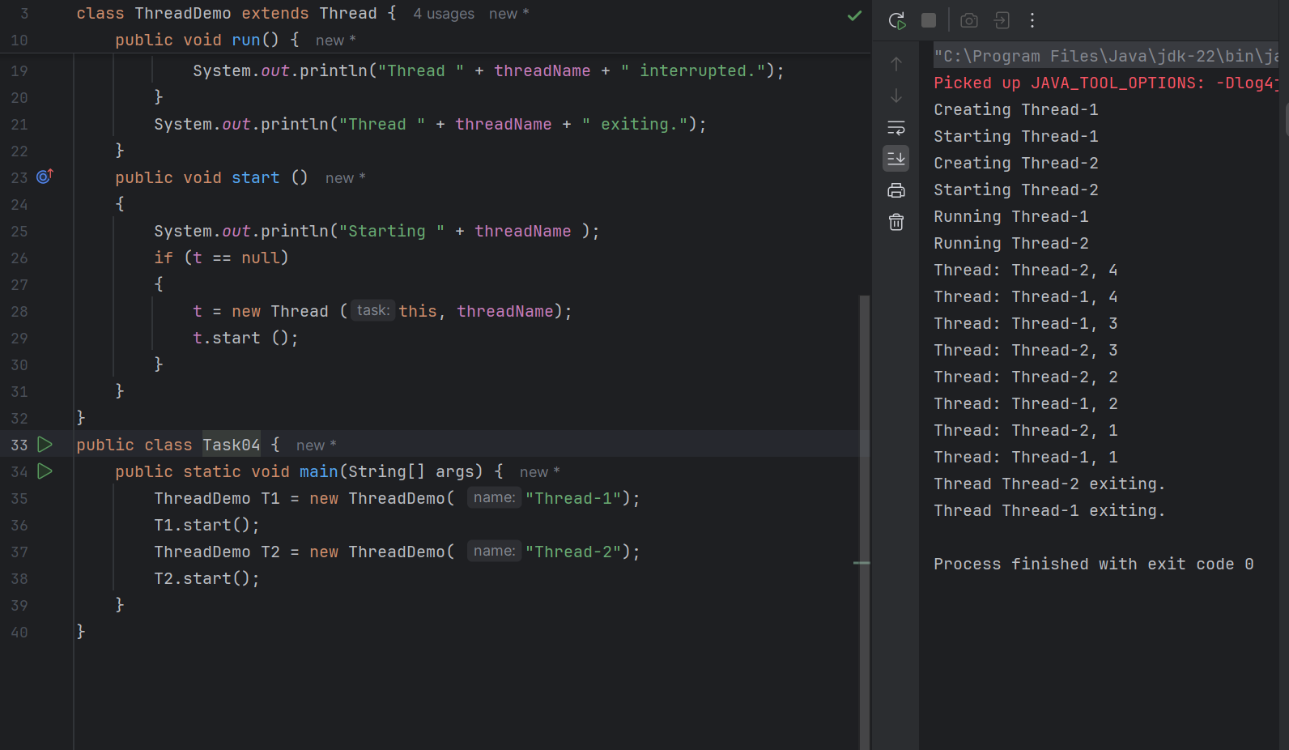

Task 05
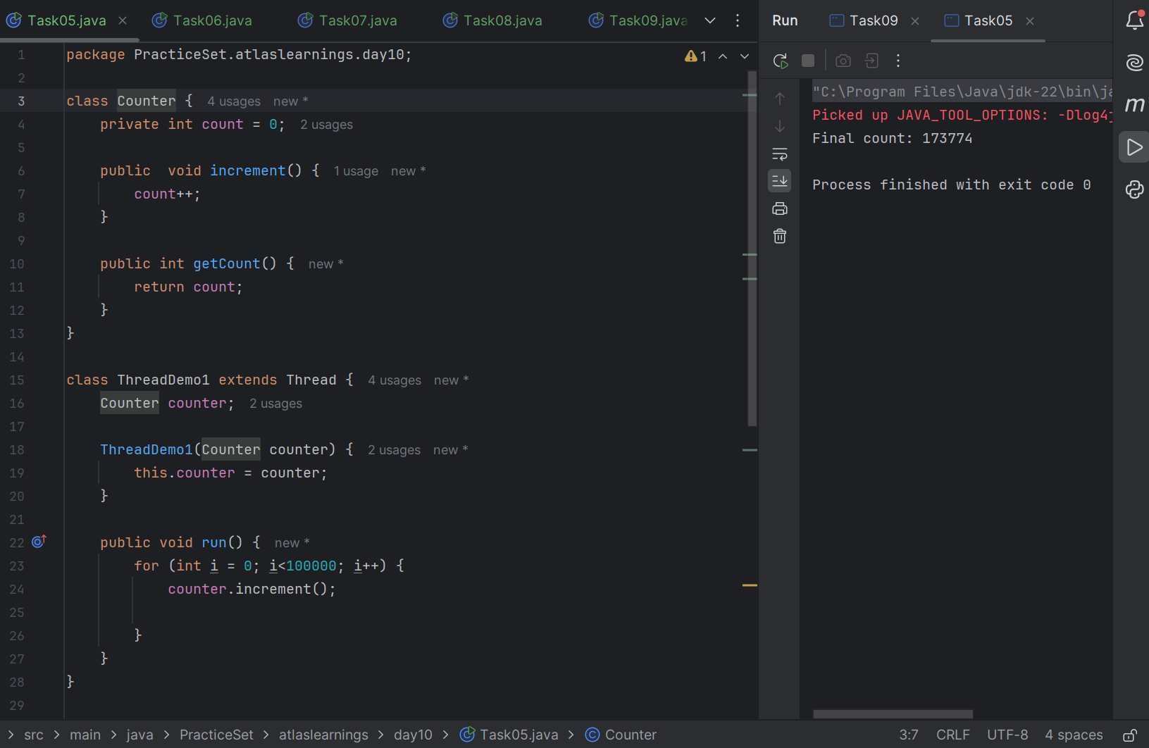
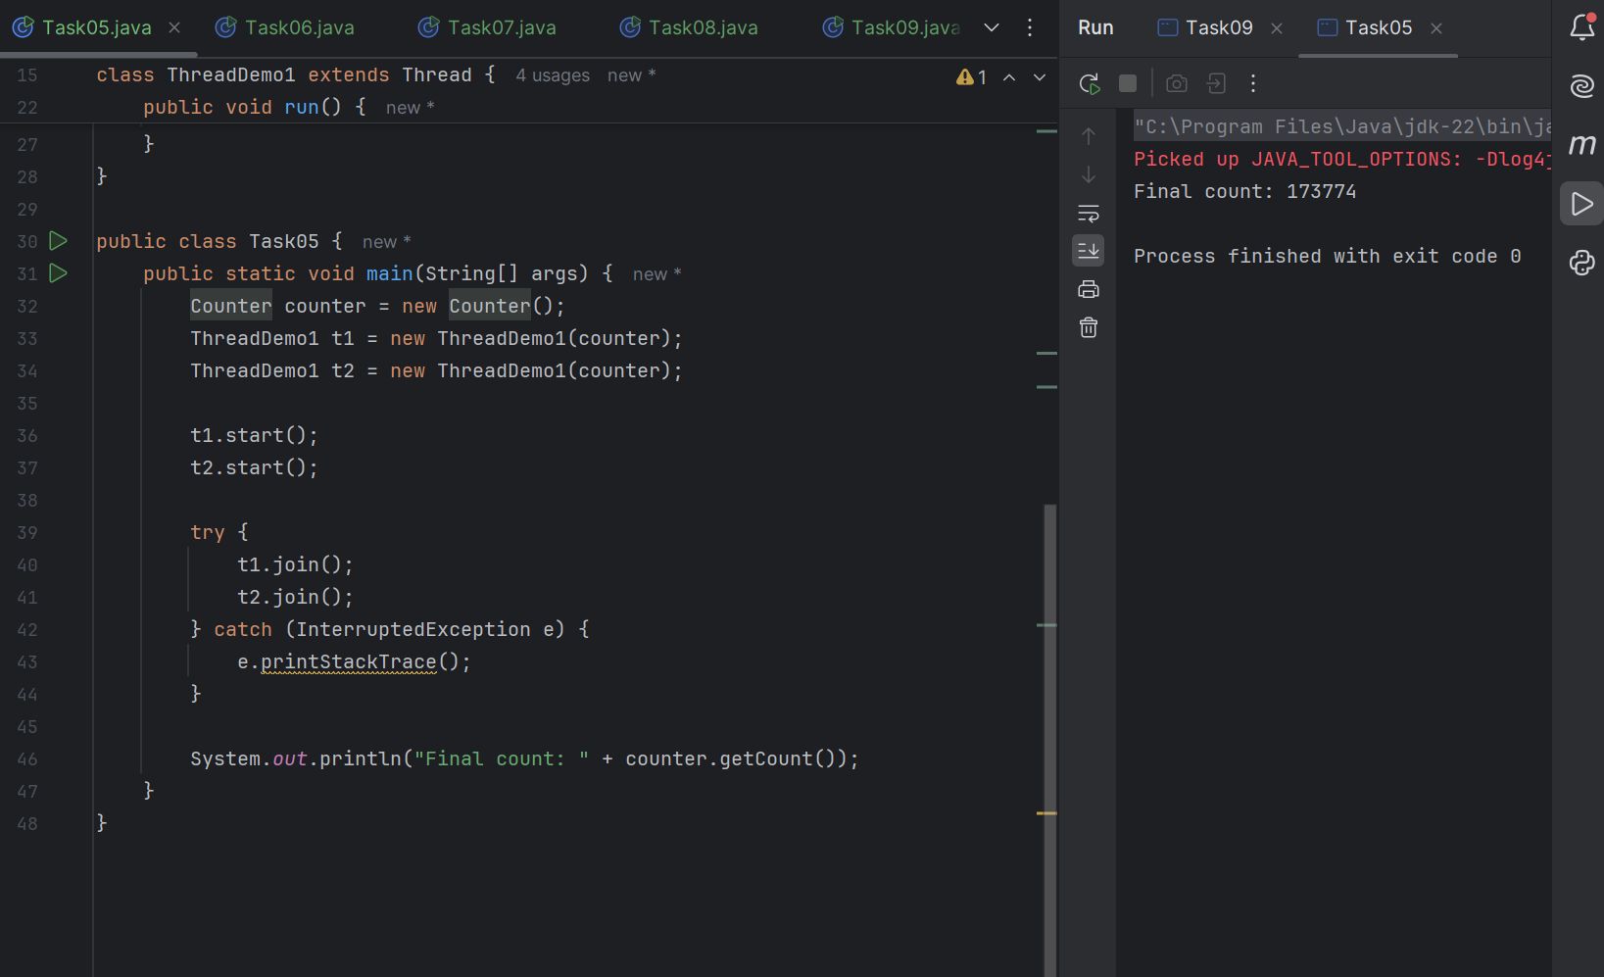

Task 06

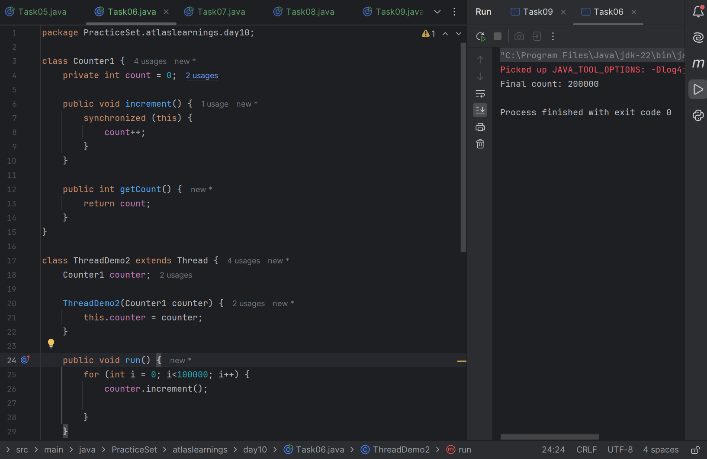
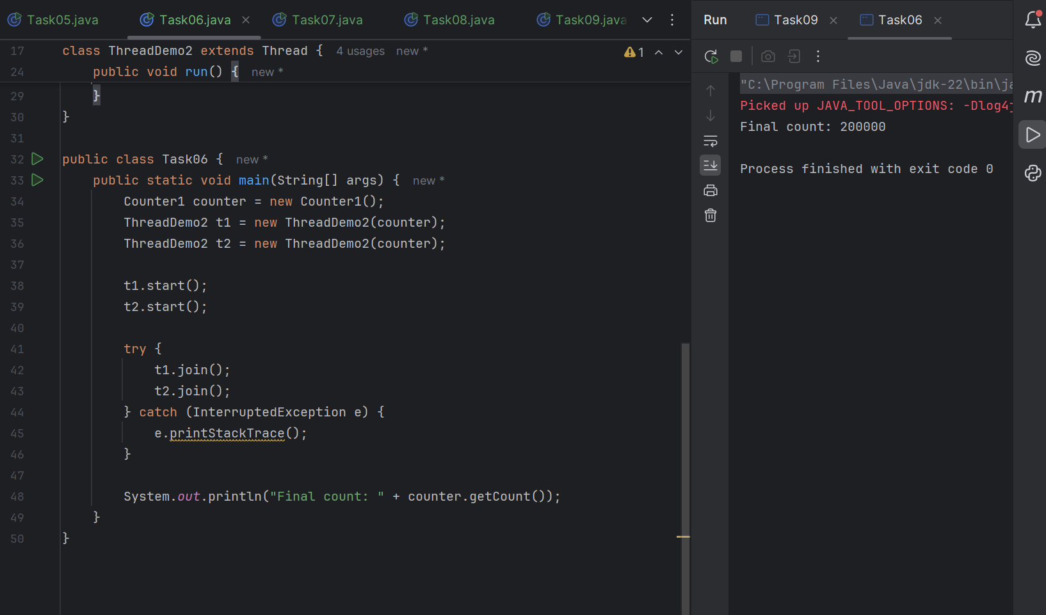

Task 07
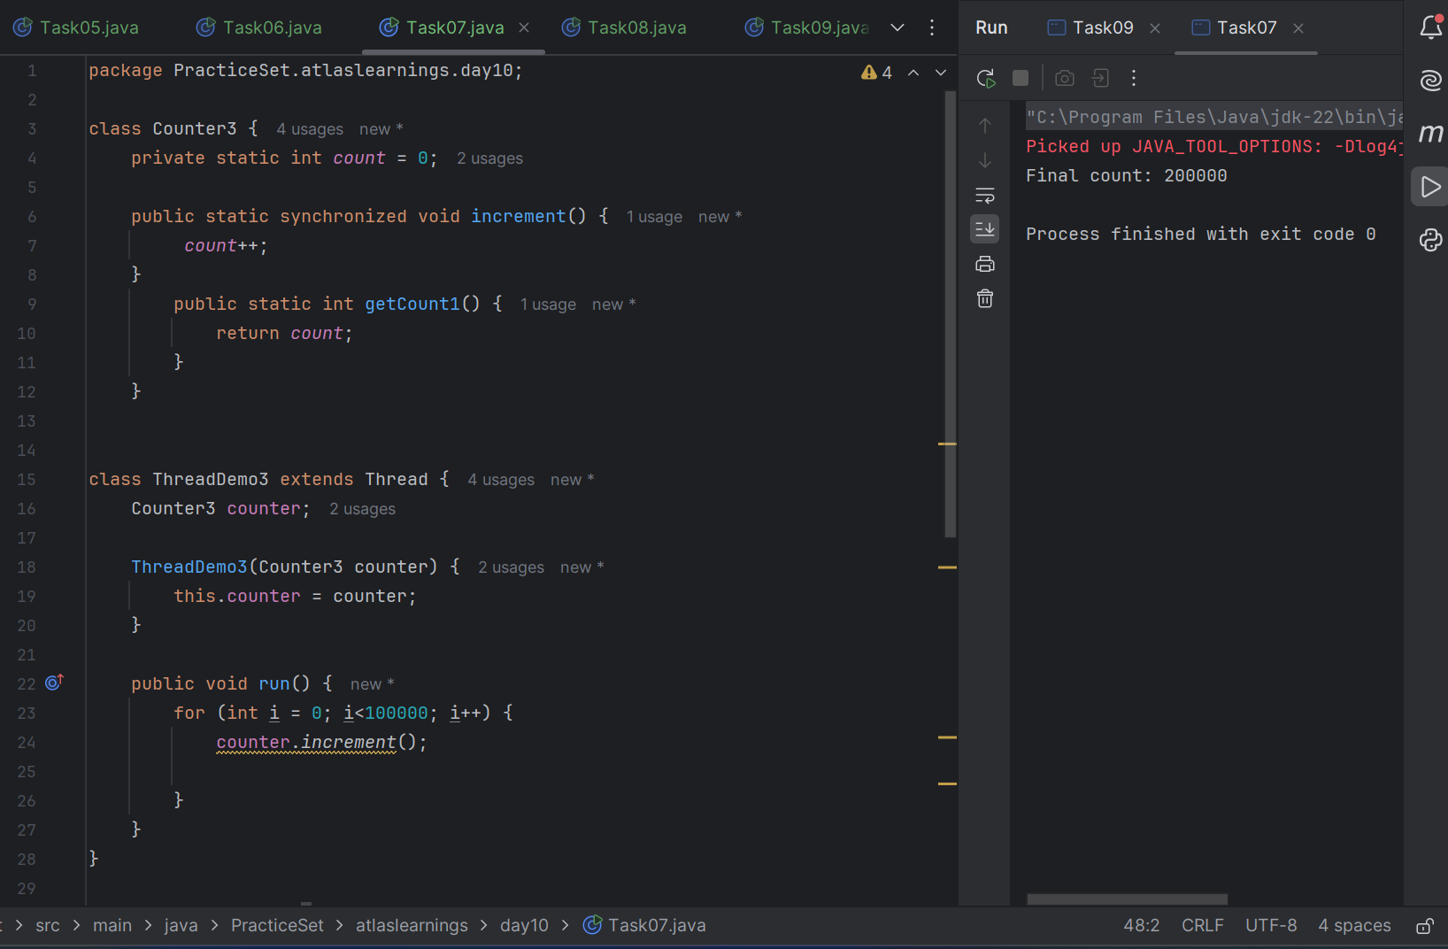

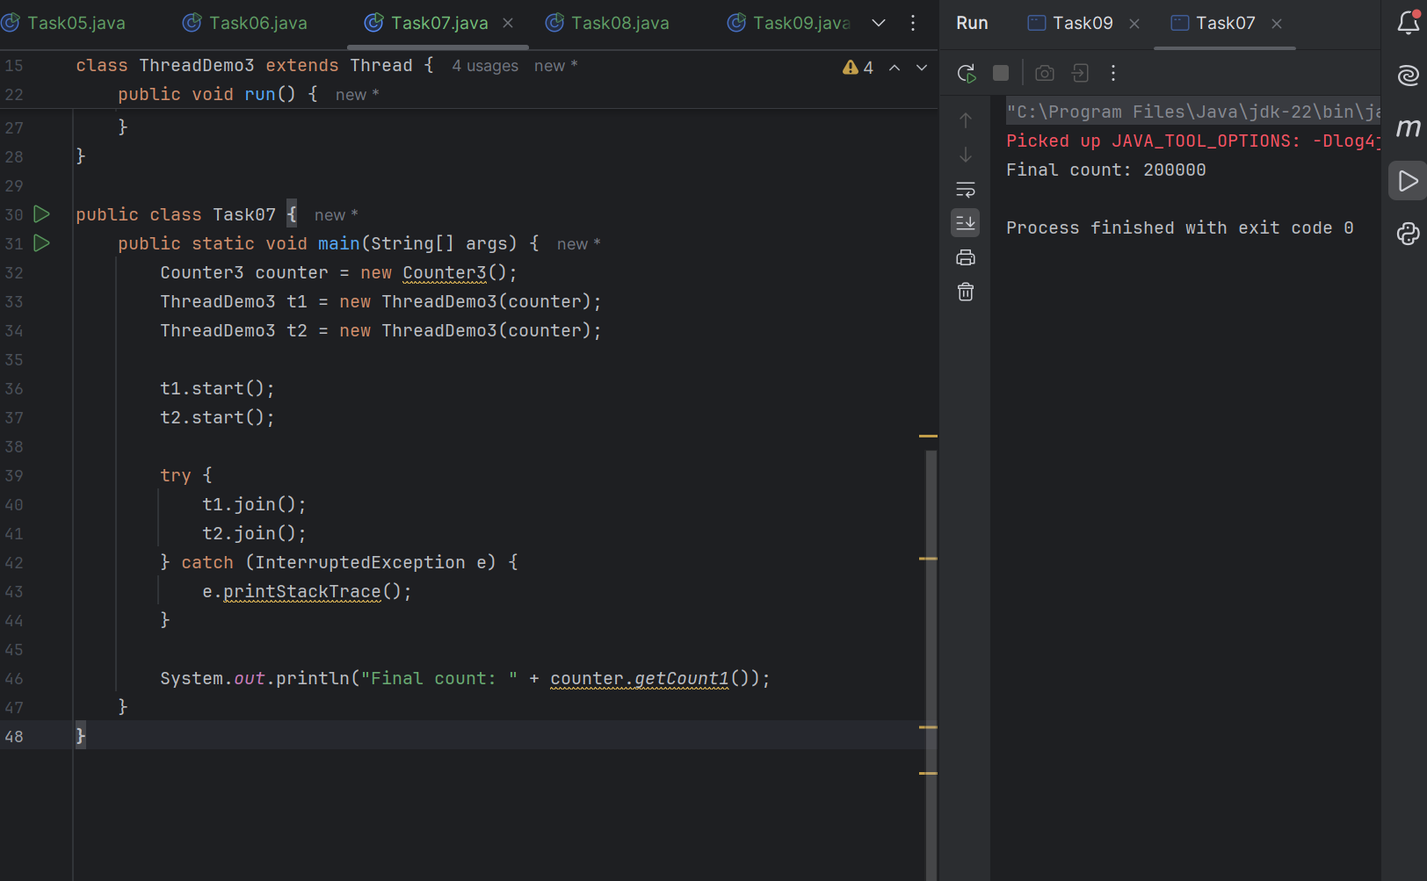

Task 08
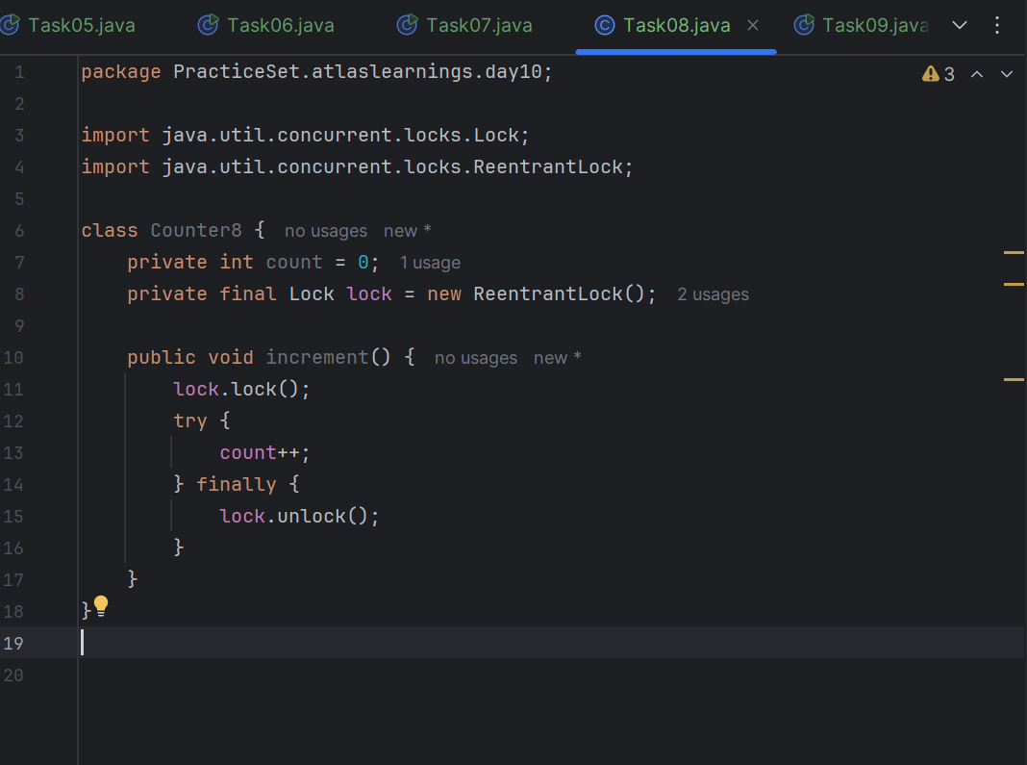
Task 09
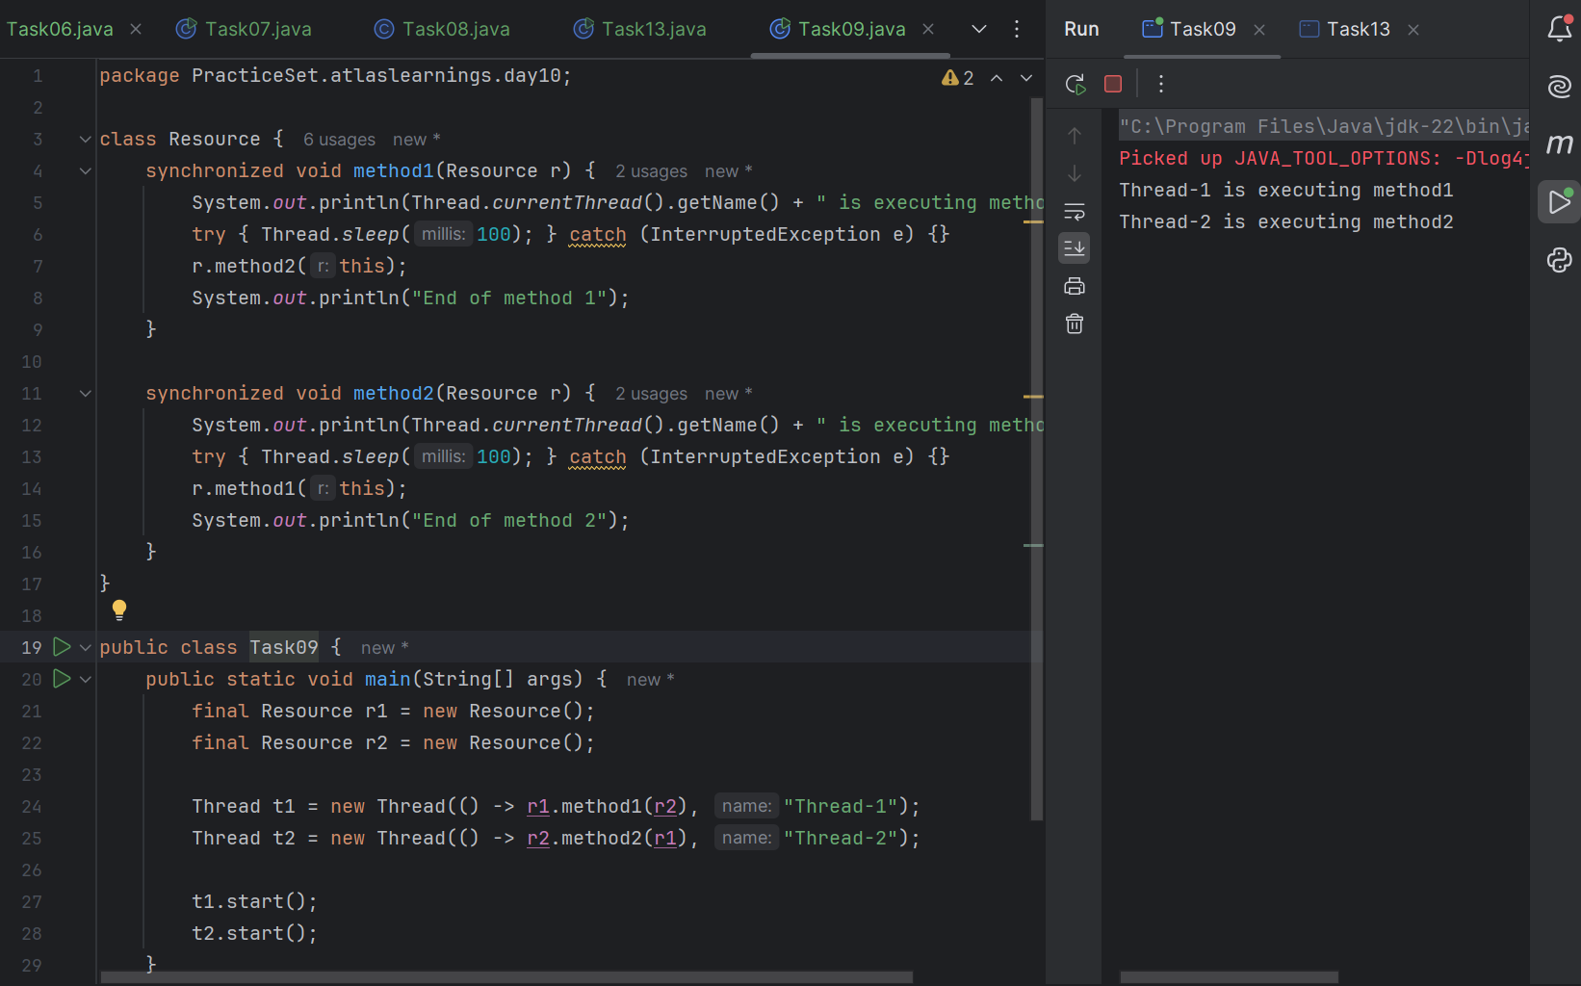

Task 10
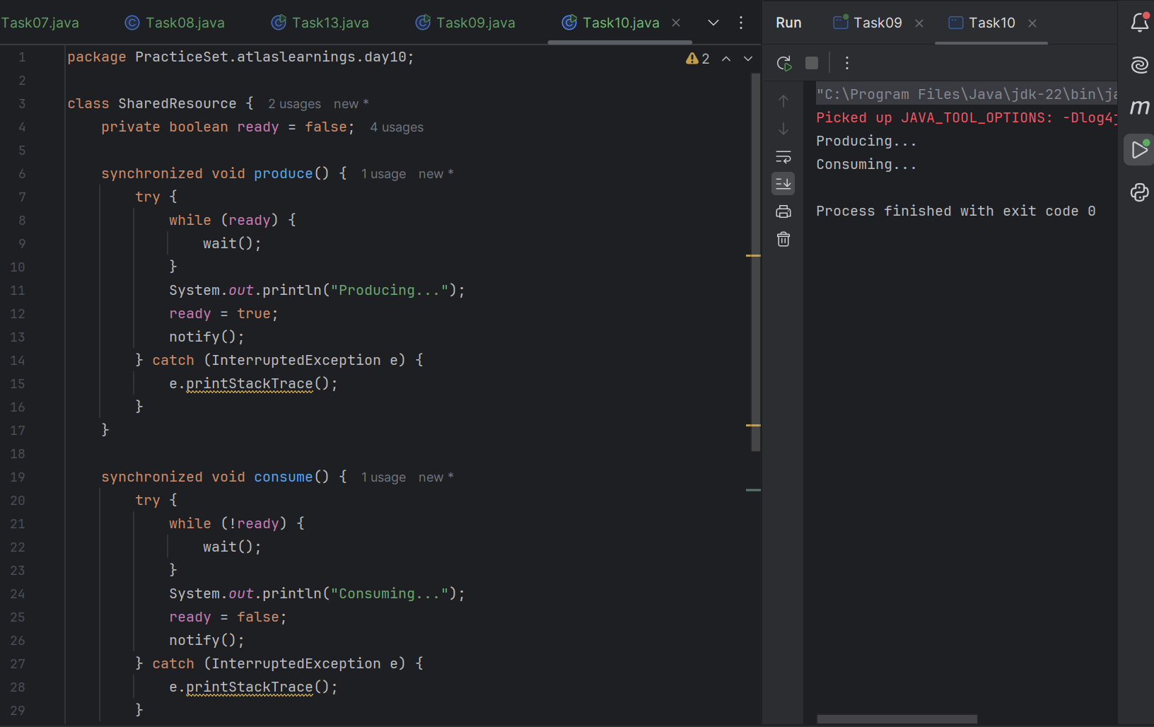
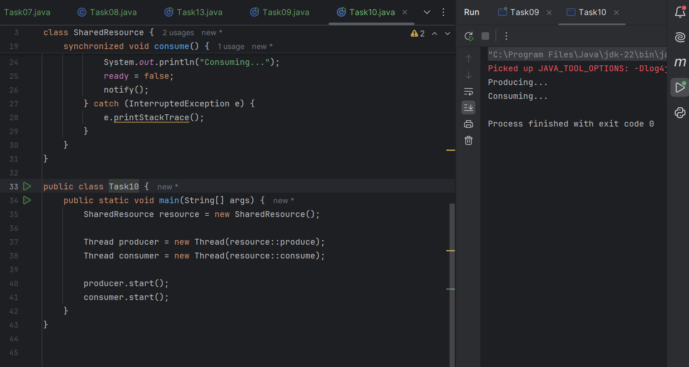

Task 11
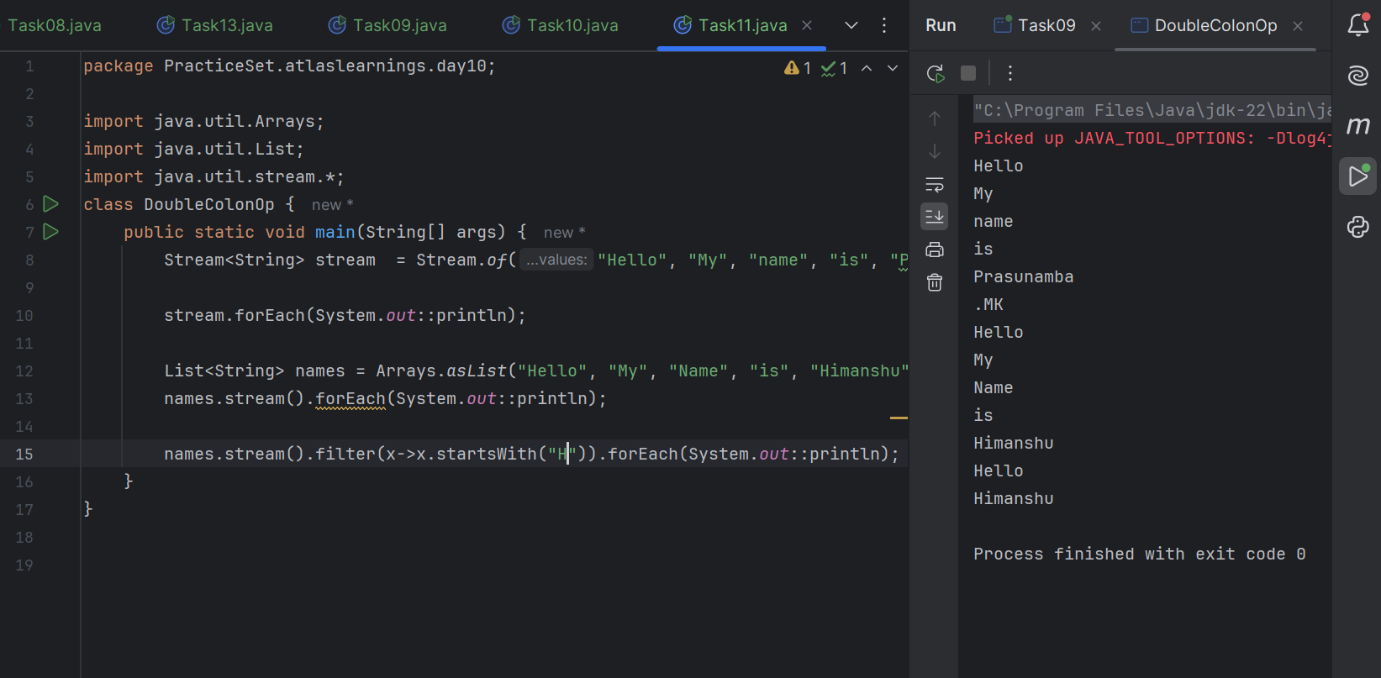

Task 12
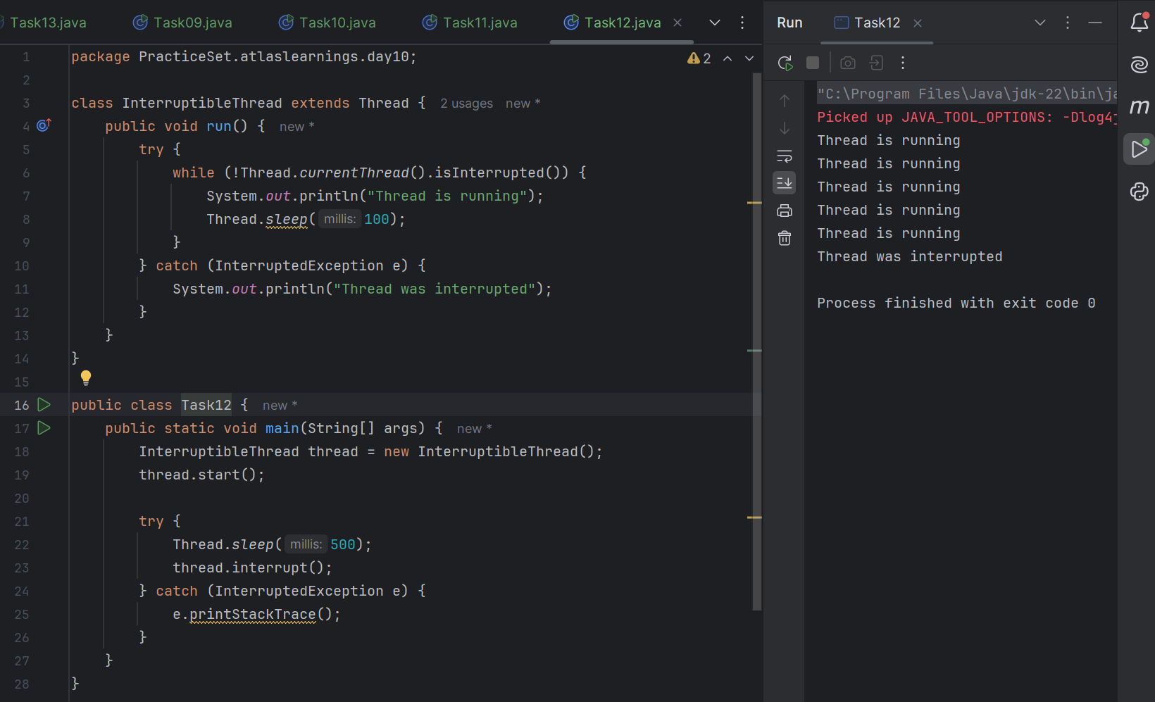

Task 13
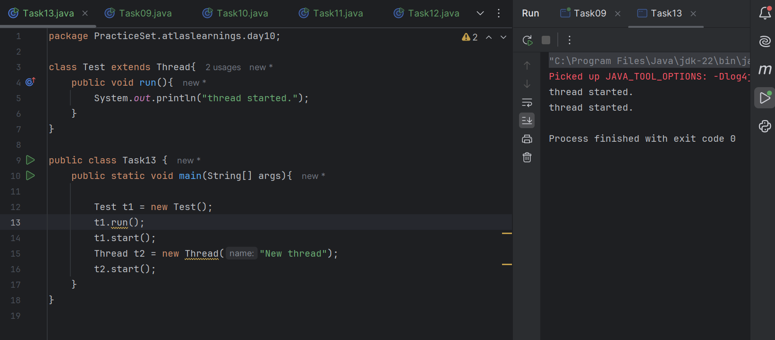

Task 14:
What are Daemon threads?
A daemon thread is a background helper thread. It works behind the scenes to support the main tasks of a program.
Daemon threads run in the background.
They automatically stop when all normal threads are done.

Task 15
